**EDWH DBA ANALYSIS**

|  |  |
| --- | --- |
| **06/08/2021** | **SANJEEB** |
|  |  |

|  |  |
| --- | --- |
| **Name** | **Value** |
| **Database name** | **oltp143** |
| **Database Version** | **12.1.0.2.0** |
| **Database Size** | **~31TB** |
| **Datafiles** | **1634** |
| **Configuration** | **2 Node Cluster with VTE** |
| **Database memory** | **316226468 kB** |
| **CPU** | **32 Genuine Intel** |
| **OS** | **2.6.32-754.39.1.el6.x86_64** |
|  | **Intel(R) Xeon(R) Platinum 8168 CPU @ 2.70GHz** |

**DB USAGE HISTORY**

|  |  |
| --- | --- |
| **Name** | **Value** |
| logons cumulative | 2,046,023 |
| logons current | 460 |
| user logons cumulative | 87,143 |

|  |  |
| --- | --- |
| SESSIONS_CURRENT | SESSIONS_HIGHWATER |
| 362 | 773 |

|  |
| --- |
| Name High Mark |
| Maximum Number of Active Sessions seen in the system 378 |
| Maximum Number of Datafiles 1,634 |
| Maximum Size of the Database (Bytes) 33,283,213,574,144 |
| Number of job runs per day 6,658 |
| Oracle Database instances 2 |
| Maximum Number of Partitions belonging to an User Index 42 |
| Maximum Number of Partitions belonging to an User Table 63 |
| Maximum Query Length 297,208 |
| Size of Largest Segment (Bytes) 3,304,452,128,768 |
| Maximum Number of Concurrent Sessions seen in the database 860 |
| Maximum Number of SQL NCHAR Columns 764 |
| Maximum Number of Tablespaces 262 |
| Number of User Indexes 29,902 |
| Maximum Number of Materialized Views (User) 153 |
| Number of User Tables 32,629 |

* **Recommendation 1**

It seems many queries executed from sql developer which is leading to high amount of resmgr:pq queued Wait taking most of DB time .In past I recommended App team to check and set parameter to fix this wait event . alter system set "_parallel_statement_queuing"=FALSE scope=both sid=’*’; #This is Dynamic

This has been observed over time and this wait is 15.8% contribution to overall load.

Evidence:

|  |  |  |  |  |  |
| --- | --- | --- | --- | --- | --- |
| **Event** | **Waits** | **Total Wait Time (sec)** | **Wait Avg(ms)** | **% DB time** | **Wait Class** |
| resmgr:pq queued | 12,898 | 1.6M | 120227.7 | 15.8 | Scheduler |

* **Recommendation 2**

Top CPU CONSUMING SQL WHICH DEV TEAM SHOULD LOOK where I see our DBA TEAM in past shared some .

From:gbbed21as230v and infaadmin >

|  |
| --- |
| SQL_ID USERNAME |
| --------------- --------------- |
| 1qht9n2g8y03s DWHBATCH_USER |
| 56q9cbxbpm3ju DWHBATCH_USER |
| 1qht9n2g8y03s DWHBATCH_USER |
| 56q9cbxbpm3ju DWHBATCH_USER |
| 56q9cbxbpm3ju DWHBATCH_USER |
| 1qht9n2g8y03s DWHBATCH_USER |
| 56q9cbxbpm3ju DWHBATCH_USER |
| 56q9cbxbpm3ju DWHBATCH_USER |
| 1qht9n2g8y03s DWHBATCH_USER |
| 1qht9n2g8y03s DWHBATCH_USER |
| 56q9cbxbpm3ju DWHBATCH_USER |
| 1qht9n2g8y03s DWHBATCH_USER |
| 1qht9n2g8y03s DWHBATCH_USER |
| 1qht9n2g8y03s DWHBATCH_USER |
| 1qht9n2g8y03s DWHBATCH_USER |
| 1qht9n2g8y03s DWHBATCH_USER |

* **Recommendation 3 <TOP PRIORITY>**

This has been observed around server time 7AM till 9AM every day Utilization goes very high and load average reached beyond control also It has been observed very high resources intensive queries run during that time

**Evidence:**

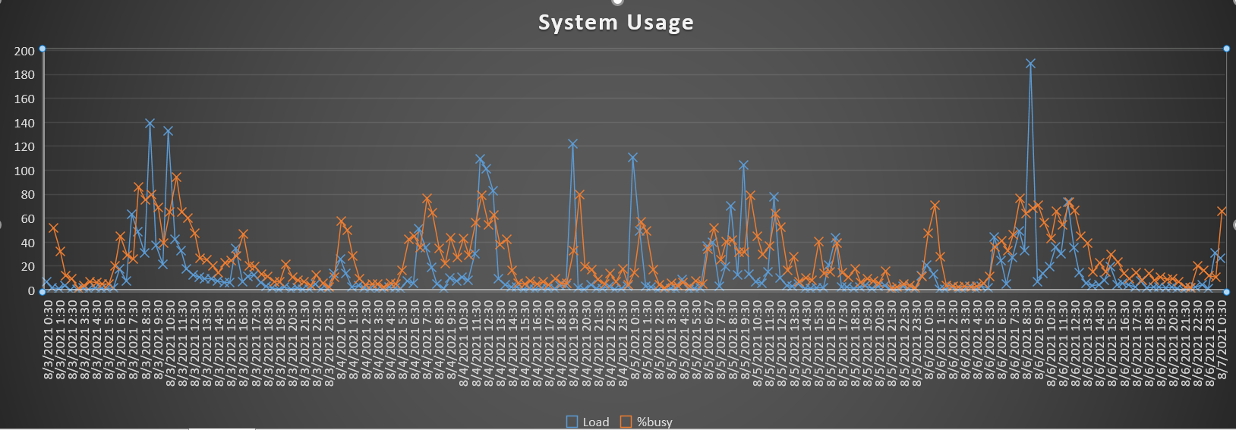

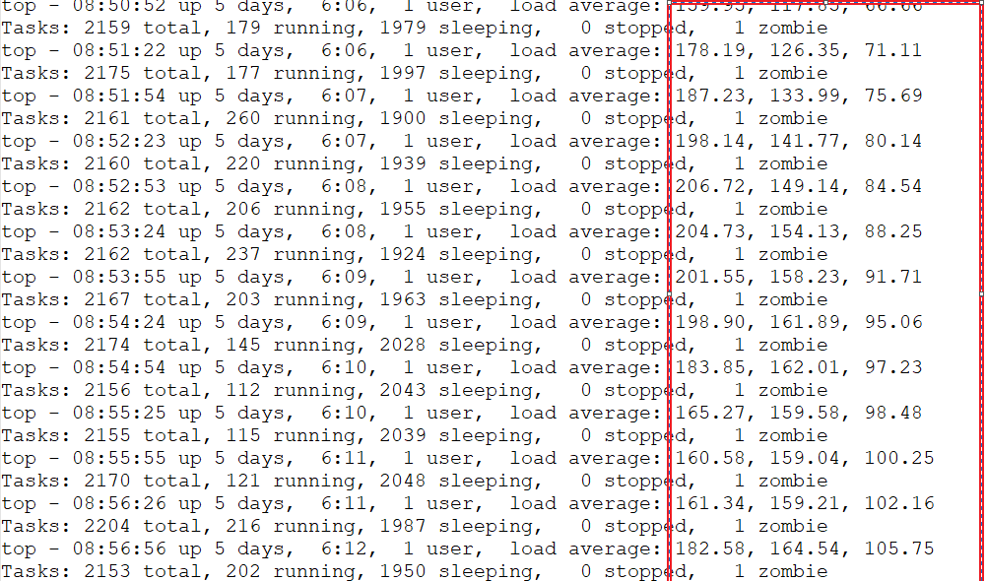

There are very high I/O Intensive Queries executes during same time .DBA team has sent several mails around same .Those queries are either need proper tuning with development expertise or just for that duration EDWH team has to hold breath tight patiently .The Other Solution is to accommodate more CPU for 2 hrs which is obviously not a feasible solution .

For the rest of the DAY CPU utilization is always under control so DBA will not recommend for CPU rather will ask app team to check Queries to optimize with Development team’s help .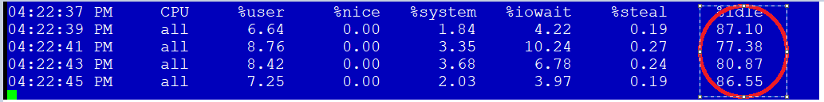

I am sharing some of queries (sqlid) which are majorly cause of high I/O and High buffer gets leads to excessive load on server .I can bet these queries will not able to sustain even if we will increase CPU .

Also, observe that, when these jobs run it just picks one node/one instance , which looks like weird to me as application should be RAC aware and should utilize both Node for this Job.

Evidence: Around same time Load average from **Node 2** for date 6th Aug 2021 is really low ,

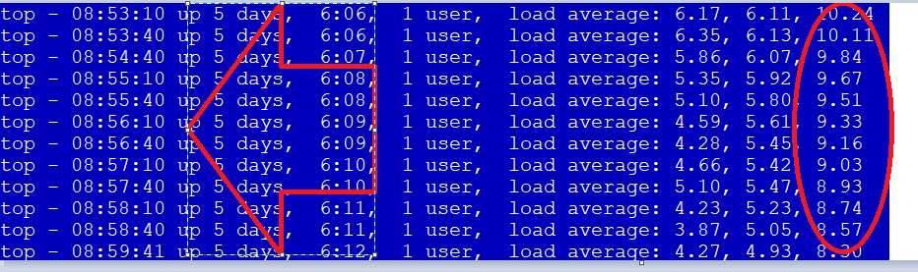

Whereas see same Time Load from Node 1 is very high :average 100+

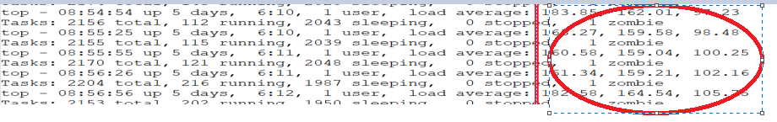

High intensive Oltp143 queries are also impacting other job on **oltp148** as both shared same servers /storage .

**Evidence High Usage for a particular Time**

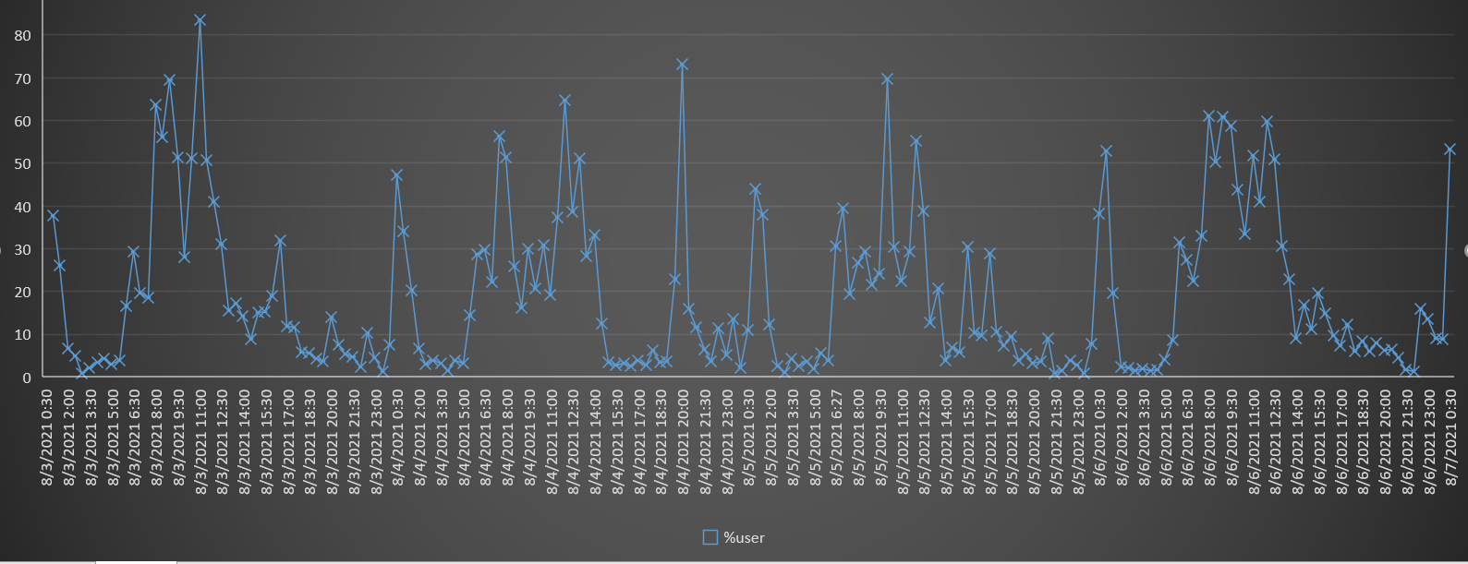

**Some Evidence with SQL IDS causing stress to system: on** Oltp143

App team Need to fix /Check and re write These Queries: DBA has no application knowledge so would not be able to help.

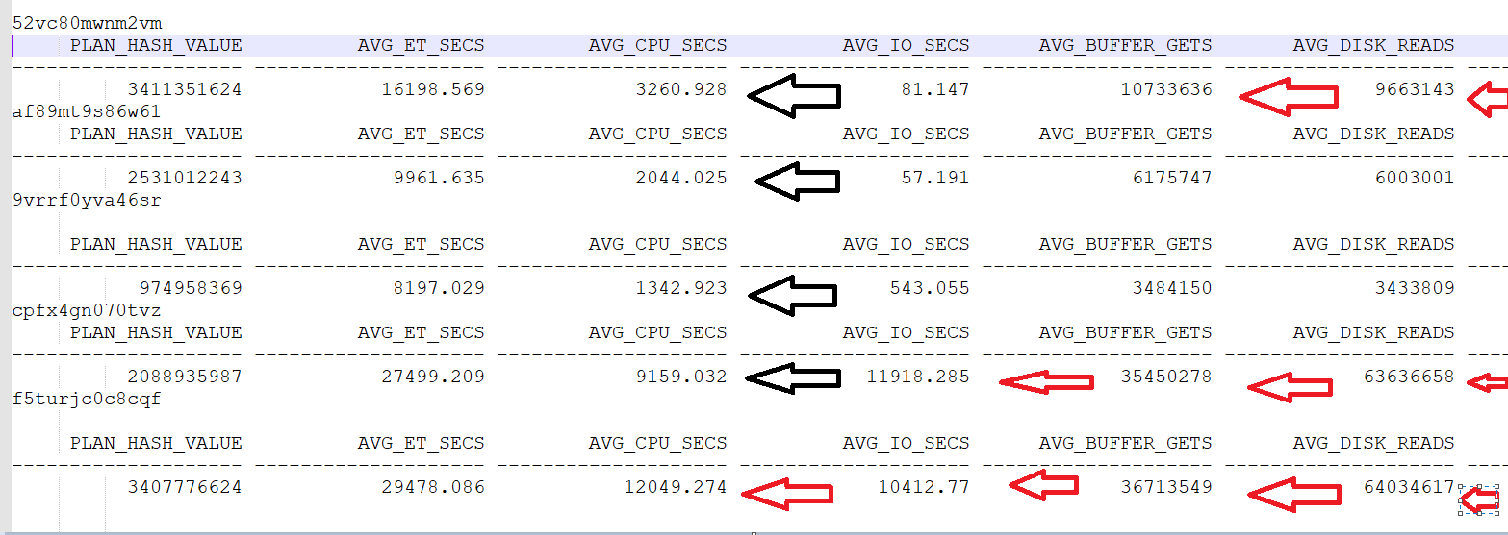

Most of them are coming from:

|  |
| --- |
| pmdtm@gbbed21as230v (TNS V1-V3) |
| pmdtm@gbbed21as230v (TNS V1-V3) |
| pmdtm@gbbed21as230v (TNS V1-V3) |
| pmdtm@gbbed21as230v (TNS V1-V3) |
| pmdtm@gbbed21as230v (TNS V1-V3) |

* **Recommendation 3(co:))**

We Have scope to increase SGA allocation as % used is not that high so I have recommendation to set to 95G .This needs downtime so should be accommodate with a CO

Memory Statistics

Host Mem (MB): 308,814.9 308,814.9

SGA use (MB): 69,632.0 69,632.0

PGA use (MB): 16,630.7 7,033.1

% Host Mem used for SGA+PGA: 27.93 24.83 >We have Scope to increase SGA even Though We have AMM we should set this or not set at all .I noticed traditionally this has been set (with current value to 68G ).

I have bumped up only will be reflected post DB restart .This will reduce potential latching observed in database due to memory usage and also will increase memory read and reduce physical Read .

SQL> alter system set sga_max_size=95G scope=spfile sid='*';

System altered.

SQL> alter system set sga_target=95G scope=spfile sid='*';

System altered.

* **Recommendation 4**

It has been observed cursor Usage is high so have recommendation to increase to 4000 and monitor the usage.

PARAMETER VALUE USAGE

---------------------- -------------------- -----

session_cached_cursors 50 ####% >This means usage is very high and not able to determine the current usage .

* **Recommendation 5**

Found some Duplicate kernel value need to remove and keep as recommended below

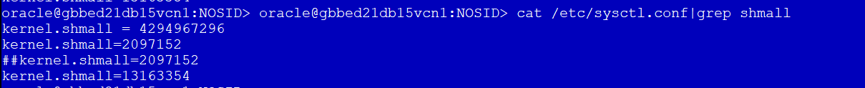

**Increase Memlock at OS level:<Unix Task > This is very important for high end database server to set proper value**

New Value should be:

oracle    soft     memlock  201326592

oracle    hard     memlock  201326592

|  |
| --- |
| kernel.shmall=77748736 |
| kernel.shmmax = 100719476736 |

Server: gbbed21db15vcn1/2

**Need Downtime**

* **Recommendation 6**

HugePages is crucial for faster Oracle database performance on Linux if you have a large RAM and SGA. If your combined database SGAs is large, you will need HugePages configured.

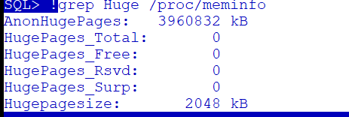

The default page size is 4 KB and we would suggest implementing the Huge Pages on the system to improve the performance. Page size is set 2MB instead of 4KB There are couple of important benefits of Huge Pages:

• Memory used by Huge Pages is locked and cannot be paged out.

• Example: With the page size of 2MB, 12GB SGA will have only 6144 pages as compared to 3.1 million pages without Huge Pages setup.

This will drastically reduce the page table size. Also, Huge Table memory is locked and so SGA can’t be swapped out. The working set of buffers for the paging/swapping daemon will be smaller

Recommendation: We suggest implementing the huge pages on linux to improve the performance. This can be parked for now and go with lower priority.

**Need Unix+DBA team with downtime**

* **Recommendation 7**

PGA is core component for Oracle instance performance for performing efficient sort operations and hash joins during the query processing. Findings: The PGA is  configured with underscore parameter 95GB memory allocation for PGA with AMM. Pga_aggregate_limit value is set to zero which makes to PGA to grow unlimited based on the physical RAM availability. Recommendation: we recommend setting the pga_aggregate_target value from 0 to 50 GB in all the RAC nodes. Also remove the underscore  pga_aggregate_limit parameter and its default value is double the pga_aggregate_target value.

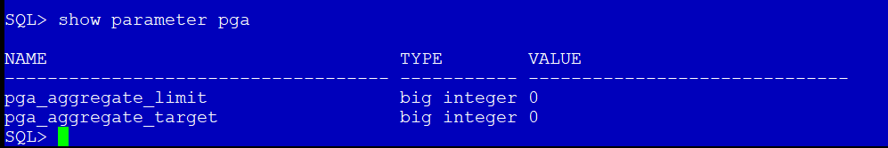

NB:This Has been implemented post DBA suggestion

* **Recommendation 8**

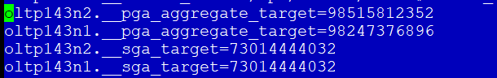

With AMM, oracle will try to tune both SGA and PGA and with current settings, we observed PGA is set to 95GB with underscore parameters. These settings are causing 95GB to be reserved for PGA and remaining is allotted to SGA with auto tuning which is from total Memory allocated .Which could be the reason frequent flush of good execution plan .

memory_max_target                    big integer 160G

memory_target                        big integer 160G

Remove all underscore parameter with Downtime .

* **Recommendation 9**

I was reviewing oltp148  it seems like this database is having high version count  and this is not good for any database  though list of sqlids having high version count is huge but am just keeping some fyi . I have 1 immediate suggestions we should increase session_cached_cursors to 1500 from current value 50.(NB:We should look at those queries from app side ) for **oltp148**

Usage % is not determined due to low value .Evidence below “ARROW FOR USAGE”

<**This Change Need downtime one Node at a time** >

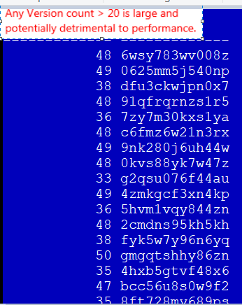

NB:OLTP148 is not highly utilized system but this is on same server as oltp143 so anything running between 6AM till 9AM server time are impacted due to oltp143 ‘s high intensive queries.

* **Recommendation 10**

I noticed there are 2 queries executed from pmdtm@gbbed21as230v which takes 18 mins and 10 mins each with High /IO are good scope of improvement and give some space for other queries .

Recommended to check on lower environment and create index on DWH_DDL_DATAMART.NARRATIVE_BRIDGE_NAB("ROW_INSERT_BATCH_NR") and DWH_DDL_DATAMART.WORKFLOW_BRIDGE_WOB("ROW_INSERT_BATCH_NR");

This will improve performance also reduce execution which out stressing on I/O .

**NB:Create Index If these are regular expected queries and not just one time**

SELECT COUNT(*) FROM WORKFLOW_BRIDGE_WOB WHERE ROW_INSERT_BATCH_NR= :1

select count(*) from DWH_DDL_DATAMART.WORKFLOW_BRIDGE_WOB;

* **Recommendation 11**

I see optimizer_index_cost_adj set to default value 100 and I would recommend this to set to 30 after proper testing on UAT

The *optimizer_index_cost_adj* parameter was created to allow use to change the relative costs of full-scan versus index operations. Re-setting this parameter to a smaller value (between 10- to 30) may result in huge performance gain for OLTP143 I see if we will reduce, we may gain some performance.

NB: This need proper testing on UAT and is Dynamic no downtime needed.

This Recommendation is applicable for OLTP148 also along with

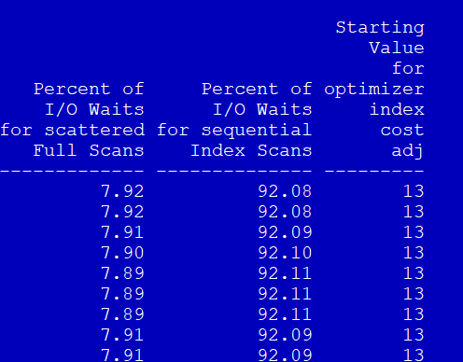

* **Recommendation 12**

**Some repetitive**

**Cursor intensive queries good to review and rewrite:**

* **Recommendation 13**

**JUNE TICKETS AND DBA’S RESPONSE:**

**Inference: There are many Queries, which need a good developer to look and work so that they can be rewrite to use proper Filter/Join.**

**There is scope to use analytical function in much SQL script, which Development team should look and fix.**

**Whole Lists are Attached some Sample where dev team needs to look .**

* **Recommendation 14**

It has been observed there are many application connect to one node only contributing to high count to a particular Node ,which mean they are not RAC aware or not using RAC features to connect Database .Which leads to uneven connections/load to a particular node .

Please check application:

Evidence:

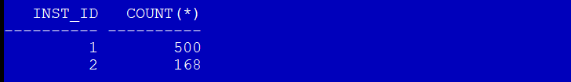

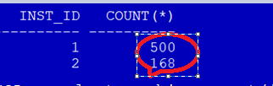

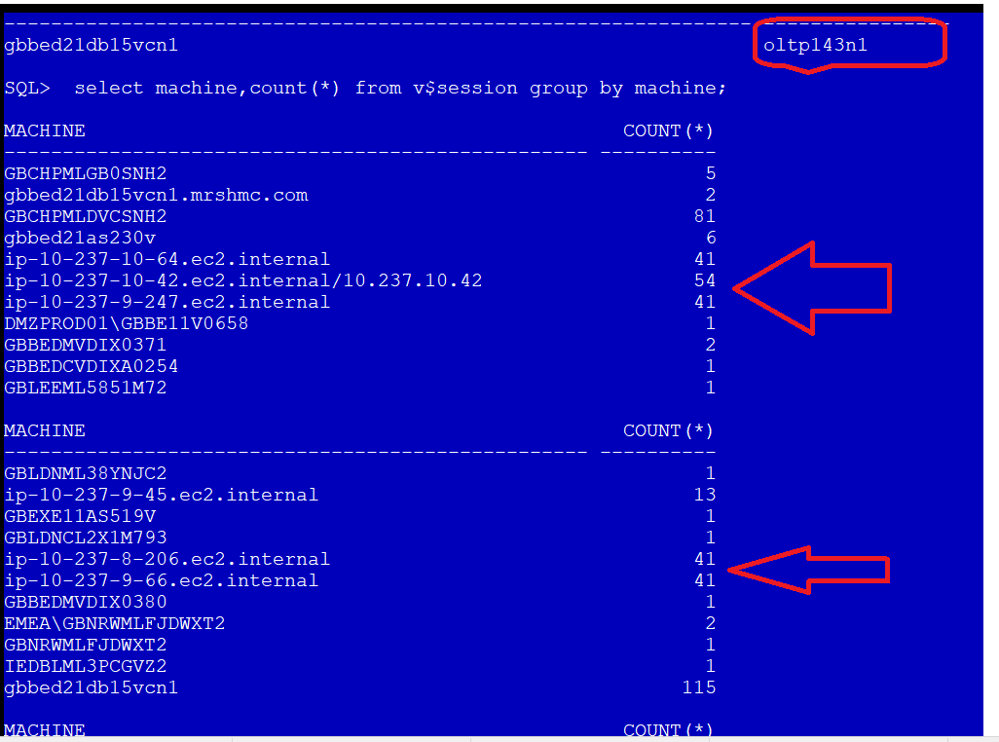

In Node 2:

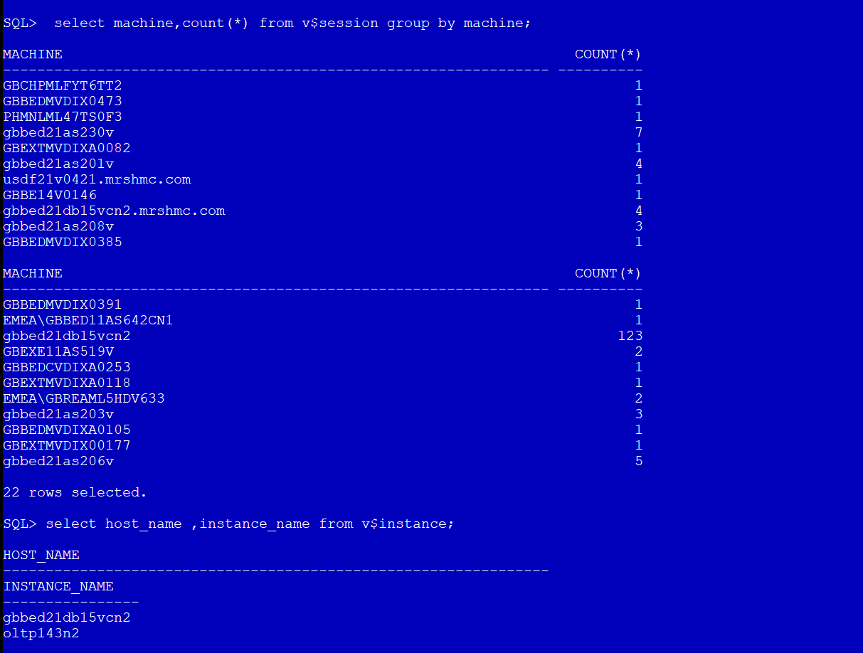

* **Recommendation 15**

There are many sqls which are facing enq - SQ contention/row cache locks waits where sequence cache size needs to be increased, app team needs to work on it..

Recommendation from Girish:

**Sample sequences:**

SEQUENCE_OWNER                 SEQUENCE_NAME                  CACHE_SIZE

------------------------------ ------------------------------ ----------

SPDMS_SRVC_OWNER               AMR_ID_S                                0

SPDMS_SRVC_OWNER               CLNT_ID_S                               0

SPDMS_SRVC_OWNER               GCS_ID_S                                0

DWH_DIL_DMSTG                  SEQ_ACT                               200

DWH_DIL_DMSTG                  SEQ_ADD                               200

DWH_DIL_DMSTG                  SEQ_CAM                               200

DWH_DIL_DMSTG                  SEQ_CEP                               200

DWH_DIL_DMSTG                  SEQ_CEX                               200

DWH_DIL_DMSTG                  SEQ_CSP                               200

DWH_DIL_DMSTG                  SEQ_CSU                               200

DWH_DIL_DMSTG                  SEQ_CTY                               200

DWH_DIL_DMSTG                  SEQ_CUR                               200

DWH_DIL_DMSTG                  SEQ_DAT                               200

DWH_DIL_DMSTG                  SEQ_GPD                               200

DWH_DIL_DMSTG                  SEQ_GUQ                               200

DWH_DIL_DMSTG                  SEQ_LAN                               200

DWH_DIL_DMSTG                  SEQ_LOC                               200

DWH_DIL_DMSTG                  SEQ_LOH                               200

DWH_DIL_DMSTG                  SEQ_LOP                               200

DWH_DIL_DMSTG                  SEQ_LOS                               200

DWH_DIL_DMSTG                  SEQ_NAD                               200

DWH_DIL_DMSTG                  SEQ_PDN                               200

DWH_DIL_DMSTG                  SEQ_PRD                               200

DWH_DIL_DMSTG                  SEQ_PRS                               200

DWH_DIL_DMSTG                  SEQ_PTY                               200

DWH_DIL_DMSTG                  SEQ_ROB                               200

DWH_DIL_DMSTG                  SEQ_RSD                               200

DWH_DIL_DMSTG                  SEQ_RSK                               200

DWH_DIL_DMSTG                  SEQ_SSD                               200

DWH_DIL_DMSTG                  SEQ_SSR                               200

DWH_DIL_DMSTG                  SEQ_SUR                               200

DWH_DIL_DMSTG                  SEQ_TID                               200

DWH_DIL_DMSTG                  SEQ_TJN                               200

DWH_DIL_DMSTG                  SEQ_TMZ                               200

DWH_DIL_DMSTG                  SEQ_TWG                               200

DWH_DIL_DMSTG                  SEQ_TYP                               200

DWH_DIL_DMSTG                  SEQ_USM                               200

SPDMS_SRVC_OWNER               SAMA_SEQ_1                              0

SPDMS_SRVC_OWNER               SDT_ID_S                                0

SPDMS_SRVC_OWNER               SES_ID_S                                0

SPDMS_SRVC_OWNER               SJE_ID_S                                0

SPDMS_SRVC_OWNER               SMFR_ID_S                               0

META_DIL_DATA                  LOAD_ID_SEQ                            20

META_DIL_DATA                  BATCH_ID_SEQ                            0

SYS                            WRP$_REPORT_ID_SEQ                      0

DBO                            ACE_SEQ                                20

DBO                            ACP_SEQ                                20

DBO                            ACR_SEQ                                20

DBO                            AGP_SEQ                                20

DBO                            AOC_SEQ                                 0

DBO                            ASC_SEQ                                20

DBO                            ATC_SEQ                                 0

DBO                            BAC_SEQ                                 0

DBO                            BAL_SEQ                                20

DBO                            ETM_SEQ                                20

DBO                            FBN_SEQ                                20

DBO                            FII_SEQ                                20

DBO                            GUY_CARP_TRANSFER_SEQ                  20

DBO                            HIST_STAT_SEQ                           0

DBO                            HUNDREDSECONDS#S                       20

DBO                            HUNSECS                                20

DBO                            MAU_SEQ                                 0

DBO                            SEC_SEQ                                20

DBO                            SET_SEQ                                20

DBO                            SQUN_QUERY_NAMES_SEQ                   20

DBO                            SSE_SEQ                                20

DBO                            STD_PARAGRAPH_SEQ                      20

DBO                            SUC_SEQ                                20

DBO                            SVP_SEQ                                20

DBO                            TAR_SEQ                                 0

DBO                            VAD_SEQ                                20

DBO                            TER_SEQ                                 0

DBO                            TRA_SEQ                                20

DBO                            OMA_SEQ                                20

DBO                            OMH_SEQ                                20

DBO                            ONC_SEQ                                20

DBO                            OPL_SEQ                                20

DBO                            DIB_SEQ                                20

DBO                            DOI_SEQ                                20

DBO                            DRF_SEQ                                20

DBO                            DTR_SEQ                                20

DBO                            E3P_SEQ                                20

DBO                            EAH_SEQ                                20

DBO                            EDR_SEQ                                20

DBO                            EES_SEQ                                20

DBO                            EFC_SEQ                                 0

DBO                            EMB_SEQ                                 0

DBO                            EMP_SEQ                                20

DBO                            ENA_SEQ                                20

DBO                            ENP_SEQ                                20

DBO                            IND_SEQ                                 0

DBO                            IRIS_CLIENT_ALT_KEY_SEQ                20

DBO                            IRIS_TRANSACTION_ALT_KEY_SEQ           20

DBO                            PEC_SEQ                                 0

DBO                            PLA_SEQ                                20

DBO                            PMA_SEQ                                20

DBO                            PML_SEQ                                 0

DBO                            PMR_SEQ                                20

DBO                            PMS_SEQ                                 0

DBO                            PRM_SEQ                                20

DBO                            PRODOFF_SEQ                             0

DBO                            PRO_SEQ                                 0

DBO                            PRT_SEQ                                 0

DBO                            PSA_ID_SEQ                             20

DBO                            PSL_ID_SEQ                             20

DBO                            PTD_SEQ                                20

DBO                            PTR_SEQ                                20

DBO                            RIC_SEQ                                 0

DBO                            RISK_HIST_SEQ                           0

DBO                            RSC_SEQ                                20

DBO                            TXN_SEQ_1                              20

DBO                            LIC_SEQ                                 0

DBO                            LIN_SEQ                                20

DBO                            LLE_SEQ                                20

DBO                            LNR_SEQ                                20

DBO                            LSD_SEQ                                20

DBO                            LSL_SEQ                                20

DBO                            THP_SEQ                                 0

DBO                            CAC_SEQ                                20

DBO                            CCC_SEQ                                20

DBO                            CCL_SEQ                                20

DBO                            CLO_SEQ                                20

DBO                            COC_SEQ                                 0

DBO                            WOP_SEQ                                20

DBO                            WPA_SEQ                                 0

DBO                            WPS_SEQ                                20

DBO                            WTC_SEQ                                20

DBO                            WTM_SEQ                                20

DBO                            XIS_SEQ                                20

GIDS_LOCAL_OWNER               GIDRL_S                                20

META_DIL_DATA                  ETL_FRAMEWORK_SEQ                      20

META_DIL_DATA                  ETL_SURROGATE_SEQ                      20

ARCH_LAC_DIL_PSTG              ISEQ$$_3280113                         20

DWH_DDL_DATAMART_INDQ          SQ_WORKFLOW_ACT_RULE_FACT_WAR          20

DWH_DDL_DATAMART_INDQ          SQ_WORKFLOW_EVENT_DIM_WER              20

**Sample sqls which are facing enq – SQ contention:**

==================================================

SQL_ID          COUNT(1)

------------- ----------

5qf1p7t4buzv6       1615

ds0pb3wtz8x64       1470

165atrdx1qq0j       1326

0kwsv6m209yk0       1280

3q1y7f12yzdza       1036

d82k36xjg0v0w        768

4pua7r2g4wh12        710

                     661

6jscfqjypcwaq        651

cbjw5hpaa8m4x        620

75jhmcfvuzgaw        575

5q801n655hj1v        569

56768k8a3j39b        565

8a0z1uvjud9tv        561

da7snazk4y078        554

ghpcvcj4tbhpq        508

6j8n3j80fpt8z        497

a3k9gm1yu97az        484

4t55ty8u9wkkg        473

ctpav412s0cmq        466

3h3tb7gs48rnt        459

7k04ww5z90p5g        456

1x9jc7xxu1amm        437

f758zwvr3amha        432

df97fuc23cy6v        426

15w04jcd00n9t        417

g6mdpabfpq2pt        414

3udfr9fgpxw2v        408

8xb73b0dsycw9        399

dp0dm8096d7tk        363

g6b82zct335w0        335

927h160by5ssd        327

a6k6bfqj42qsx        324

7c05dn40n6sam        303

14j3rchvu1b60        295

4725d150208d7        293

17c1wjw1yy9j4        293

0mzd14d3d1kqb        289

0n85c1dp6d3pd        286

5509dj3asbg25        280

cjbndvnhqza3k        272

g0nv6cp7fha5y        264

3mq9mryd420qk        263

0a3xuftqr7t5r        256

ddu1qrkt2qdnh        256

887vd8nrus9n0        254

cqbzgvbx1638b        250

0jy38xd4087kf        248

6ypymk6vdt70y        245

avs2ddph5w23p        243

4z8wzbgfjf7jg        241

5fkdtd0469j31        240

6y8zxnnhjb68d        231

27b7f112nzda1        225

610rx2g7n2brp        221

atyk7m54b8506        220

b4d783xf27420        220

6yys049zmvgka        219

574jwwwgsfa3z        210

0rgx4rxcf0dtb        209

4gv6jsya1zkru        209

a3wbuzgkp7wb7        205

5rbagk7c30wk5        204

c8ch589fcx7zx        203

dfzspkv776140        201

3x57wzbcxj3jr        200

f2zdvtztyc4cf        198

akqvncxchvz62        198

7bu8s5sst4w91        197

f6zm47vjdzs7n        197

9567zu2kbuguu        197

6za4gbg0p5vsw        194

7jkrg4fhg2zzn        191

fx8454vuhdb4c        188

67yfsdqab87s5        184

d0q5kmftv7jpw        181

amxskbtyrjk25        181

5njvhumtg79b6        180

8rqq0yznkun4h        180

dhp6uj6q2r20r        177

93gtd8t8h1ay1        177

4d5m0bqdutqp2        176

cq5fjs2udqvpz        171

f5zaa37bfrg3m        168

8hzqr49jvdzyh        166

4wbcx6uv055qc        162

25m7w8zcqa88s        162

**Recommendation 16:**

